How to set up NordVPN on GL-AR750s-Ext Travel Router
(Guide works for most Gl.inet Travel Routers)
By Derek Wang
This tutorial is to guide you on how to set up NordVPN on your GL-AR750s-Ext using the OpenVPN protocol. This also works for most Gl.inet Travel Routers, since the Gl.inet Travel Routers all use the same UI.
Required:
- A GL-Ar750s-Ext Travel Router (most Gl.inet Travel Routers work as well)
- Access to a device with internet access to a browser

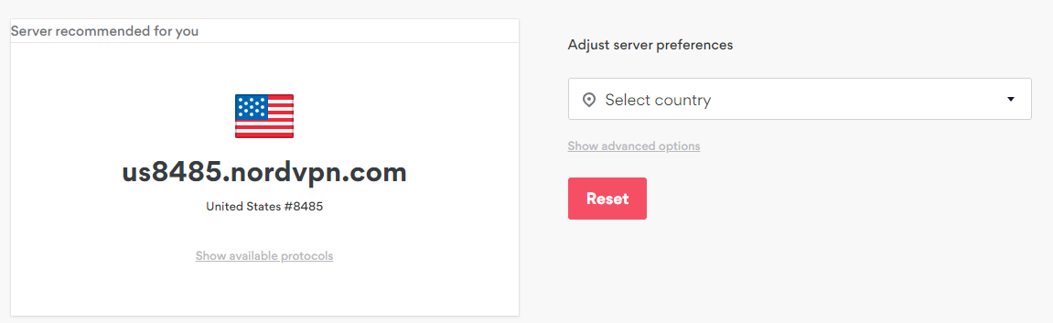
- Click Here or go to https://nordvpn.com/servers/tools/ to find which NordVPN server works best in your area or whichever country you want to connect to.
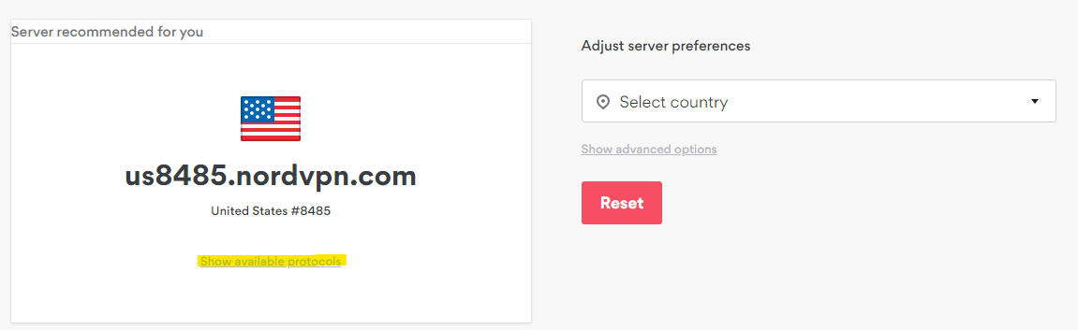
- Click on Show available protocols (highlighted in yellow).
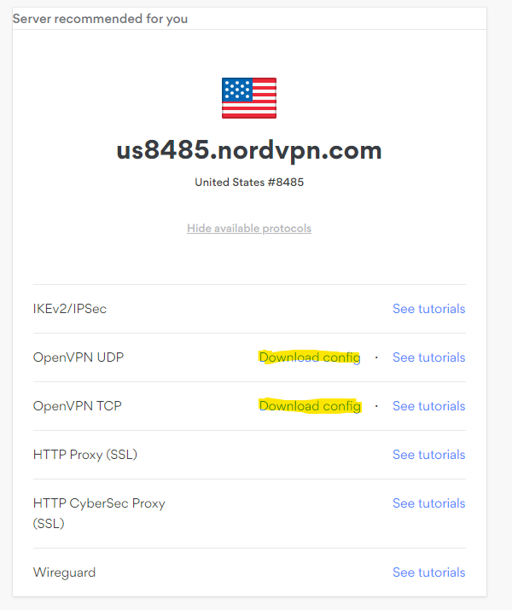

- Click Download Config for OpenVPN UDP (For Speed) or OpenVPN TCP (For Reliability) (highlighted in yellow) and save the downloaded file to your preferred location
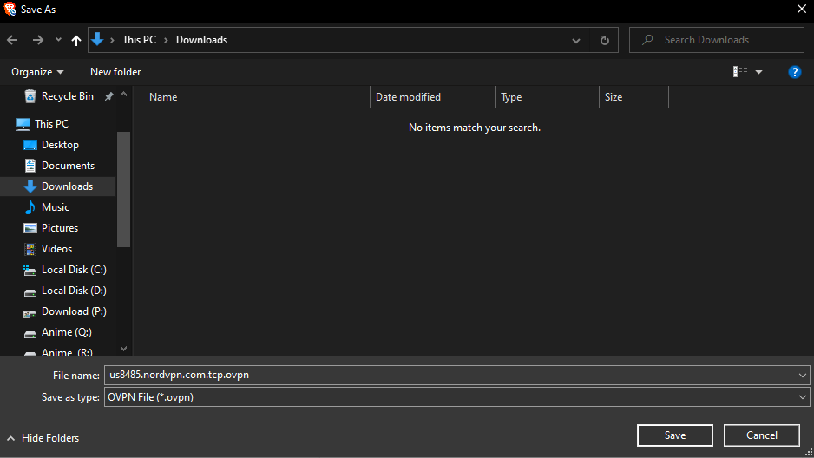
- Plug in and turn on your router if it’s not already on.
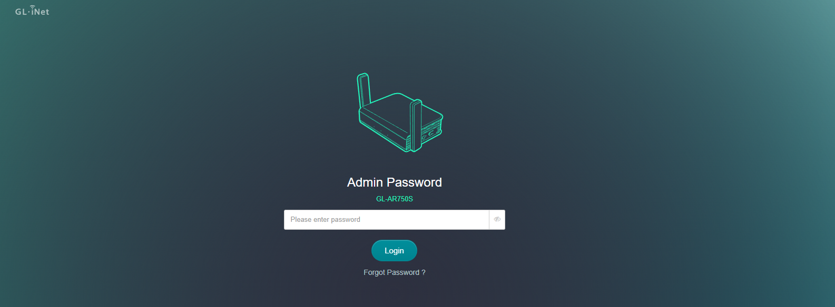
- Go to your router login page. Gl.inet Travel Routers use IP address 192.168.8.1 by default unless changed by user.
- Login using the admin Password that you created.
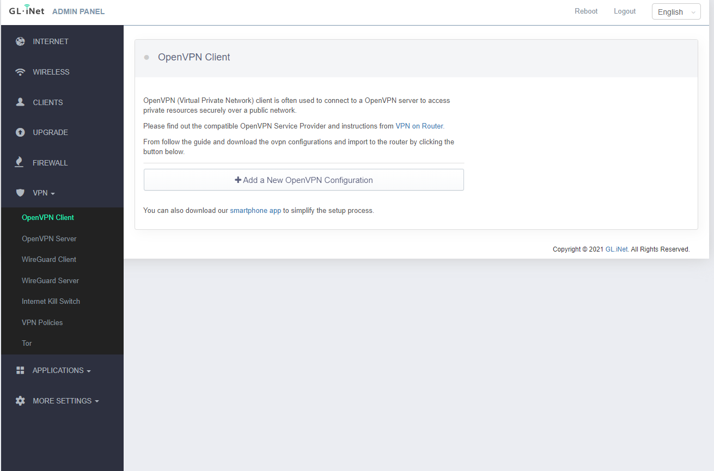
- Once logged in, on the left sidebar click on VPN▽ > OpenVPN Client

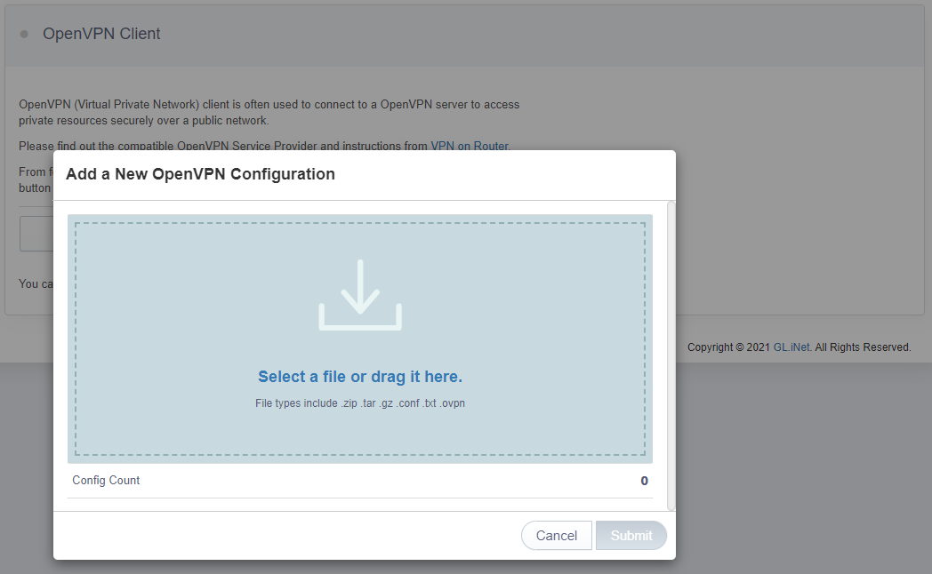
- Click on Add a New OpenVPN Configuration

- Click on Select a file or drag it here and go to the previously downloaded .ovpn file and open it.
(The file name should be ******.nordvpn.com.tcp.ovpn or ******.nordvpn.com.udp.ovpn)
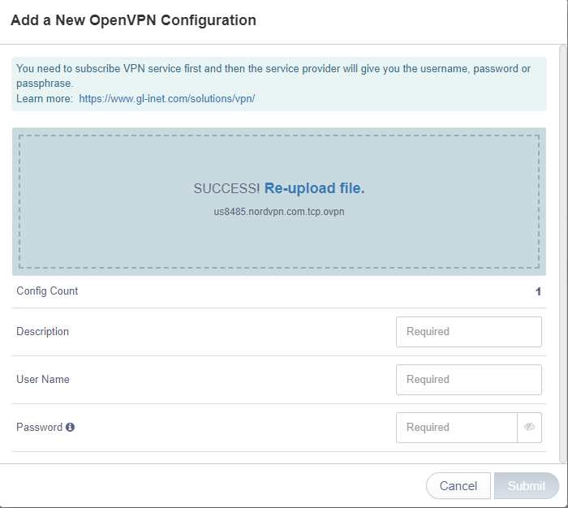
- Or you can drag the previously downloaded .ovpn file instead.

- After that the window should be asking for your NordVPN service credentials

You can find your NordVPN service credentials in the Nord Account dashboard. (https://my.nordaccount.com/dashboard/nordvpn/)
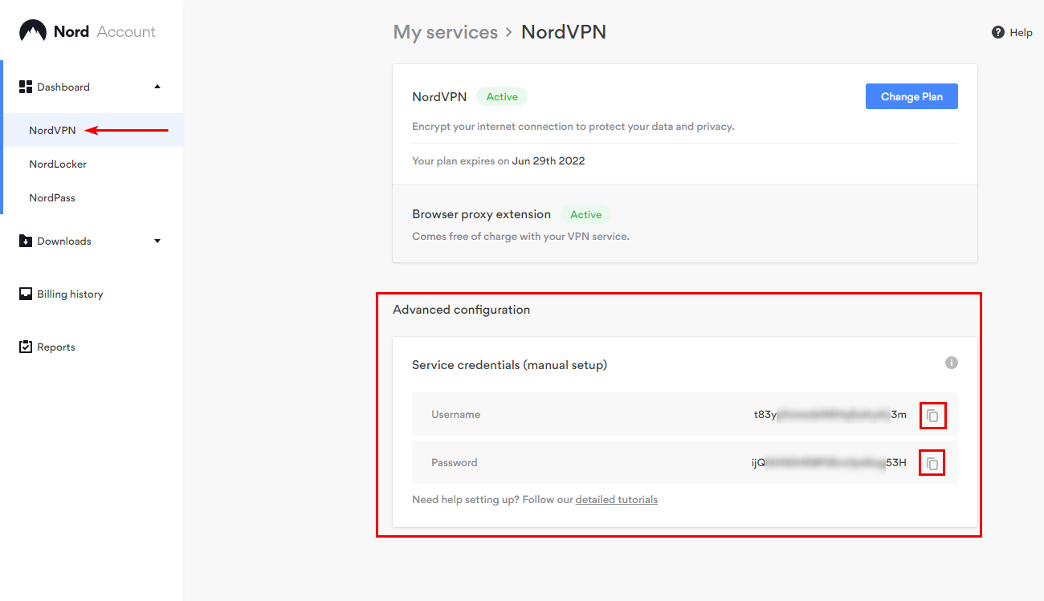

- Copy your NordVPN service credentials and paste them. Then label the description.
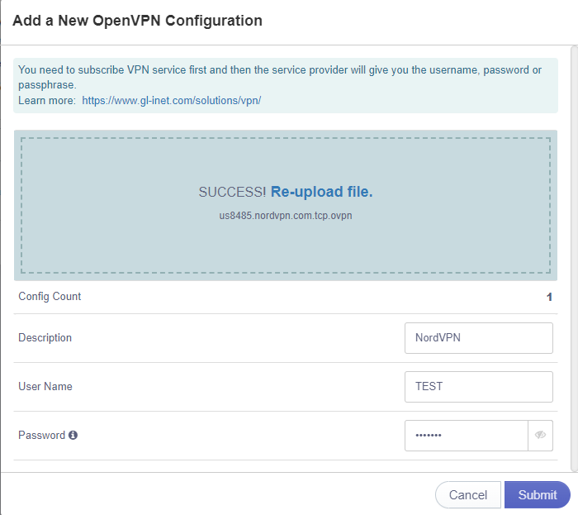
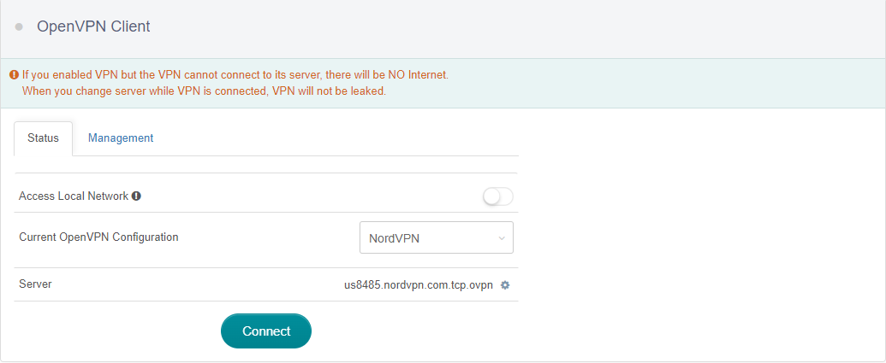
- Click connect to enable the NordVPN connection.

- Once you are connected, the connect button should change to disconnect and the top left gray dot should change to green.
If the dot is red, it means there was an error. Recheck your service credentials, if that is not the issue, try updating the device firmware and contact Gl.inet customer support if not firmware issue.
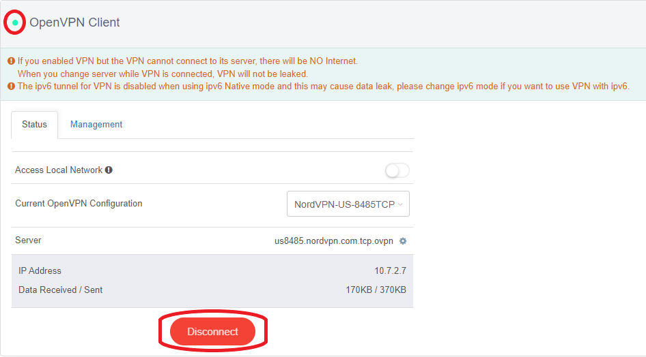
- Connect to Your Travel Router by wifi or ethernet.
- Click this link What is my IP address location? Find out here | NordVPN.
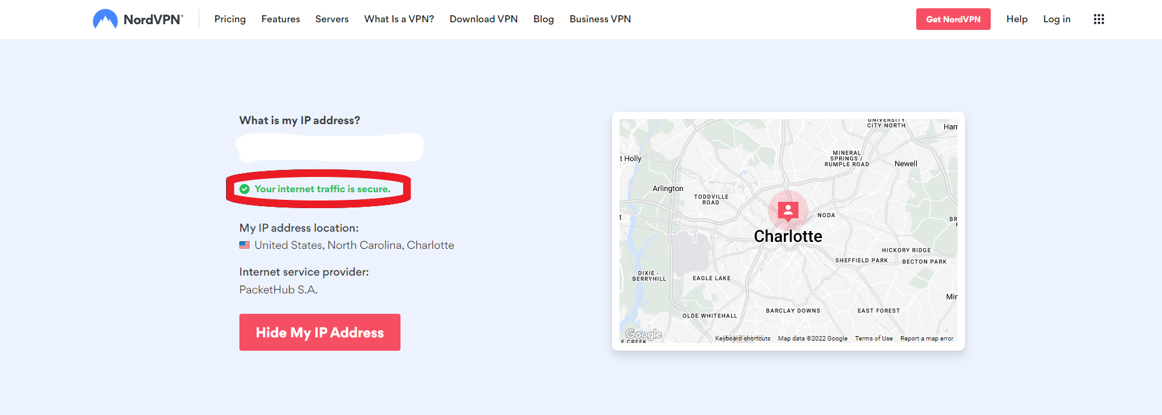
If you are connected to NordVPN, then it should show
If not connected then it should show
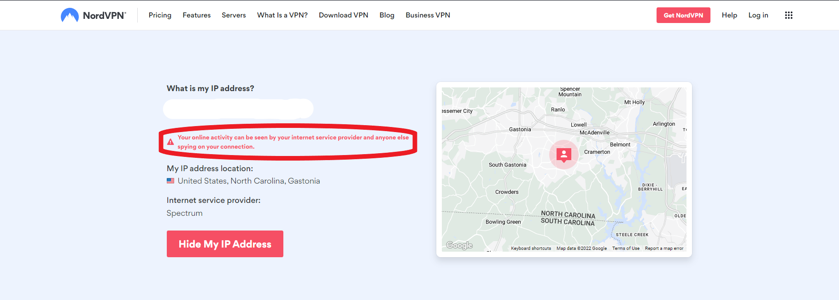
If not connected go to the travel router page and on the left sidebar click on INTERNET and check if VPN is working.
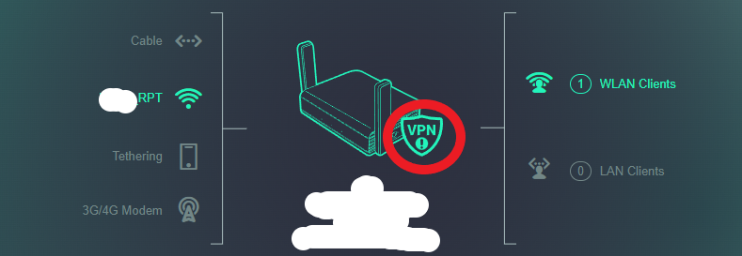
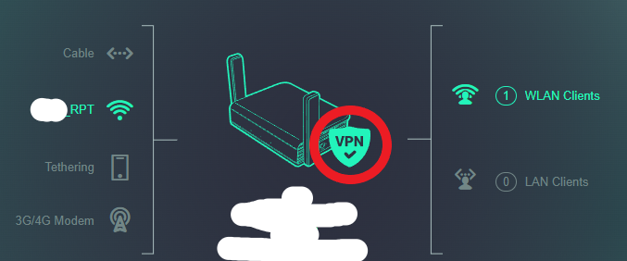
If not working, try updating the device firmware and if already updated and still not working contact Gl.inet customer support.
- Congratulations, You have successfully set up NordVPN on your Gl.inet Travel Router. Enjoy connecting to the travel router knowing that you are secured.

